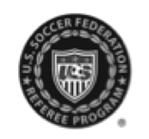

U.S. Soccer Federation Referee Program
Supplemental Referee Report
May 2012

For instances of referee assault or referee abuse, complete and submit this form, along with a U.S. Soccer Referee Report, to the competition authorities (e.g., local league, tournament director, cup coordinator, etc.), State President with jurisdiction for the competition and State Referee Administrator. Please see U.S. Soccer Federation Policy 531-9 for more information about misconduct towards game officials.
Home Team: |  |  | Score:
Away Team: |  |  | Score:
Association/League:
Division/Age Group:
Game Date:

Statement (Field limited to 1500 characters):
Enter statement here. Only facts, no opinions. Include who, what, when & where.

Name: |  |  | Date:
USSF ID Number:
Phone Number:
Email Address:

